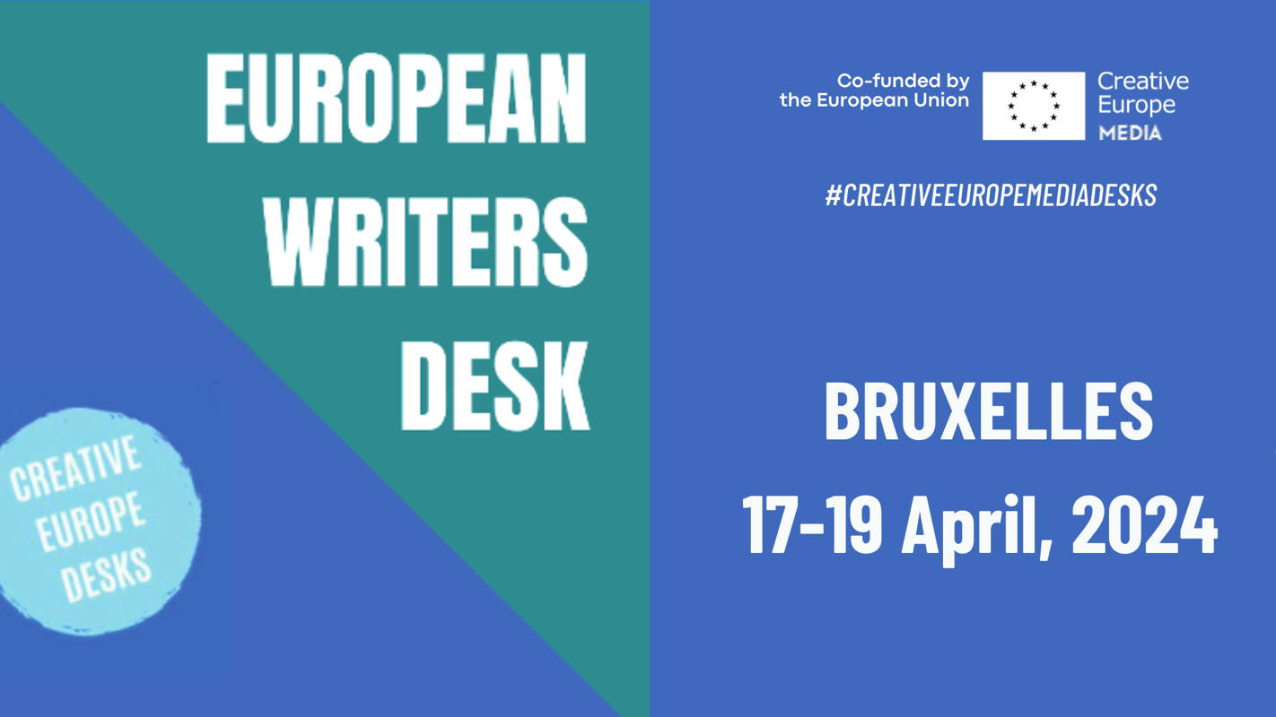

name
country

email
website
cell

Application Form 20220242

author’s CV (max. 500 characters including blanks)
motivation (max. 500 characters including blanks)

Organized by Creative Europe Desk Hamburg, Denmark and Sweden, in cooperation with the Creative Europe MEDIA Desks Austria, Belgium, Croatia, Finland, Georgia, Germany, Greece, Hungary, Ireland, Italy, Latvia, Lithuania, Netherlands, Poland, Portugal, Romania, Spain and Media Desk Suisse.

